LAB 4

1. man ls>lsdoc.is

cat lsdoc.is 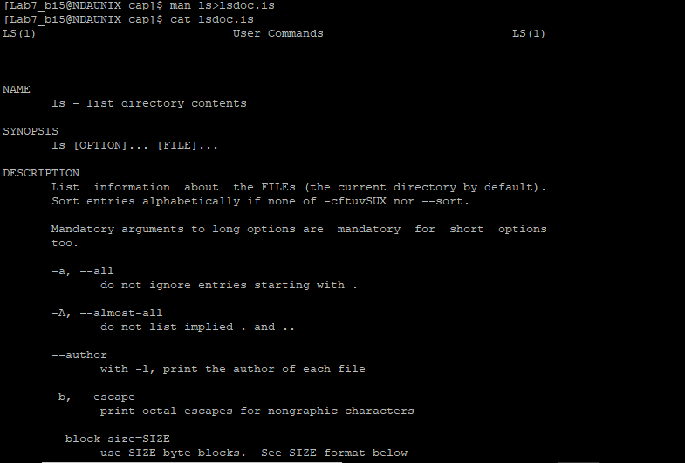

1. cat lsdoc.txt | less 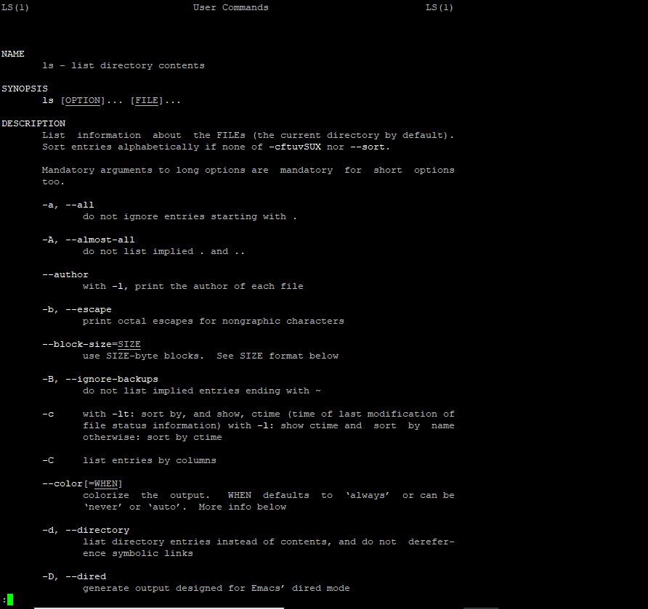
2. head -4 lsdoc.txt 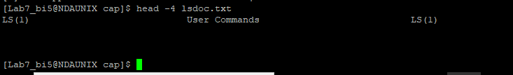
3. tail -7 lsdoc.txt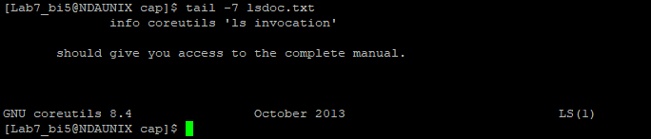
4. rm lsdoc.txt



1. cut -f3 friends.txt |sort |uniq | wc -l 
2. grep '^Ma' friends.txt 

5. ls -l | grep "^d" 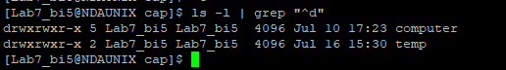
6. ls –l | grep chap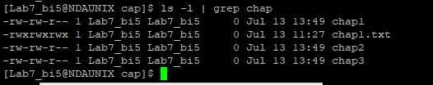
7. sort friends.txt

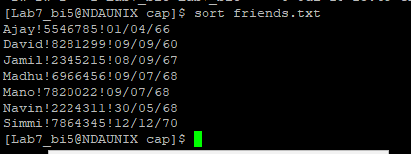

1. tr "[a-z]" "[A-Z]"< friends.txt 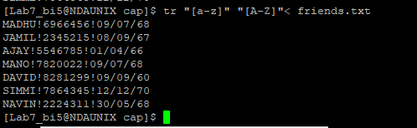
2. ls -l>>dir 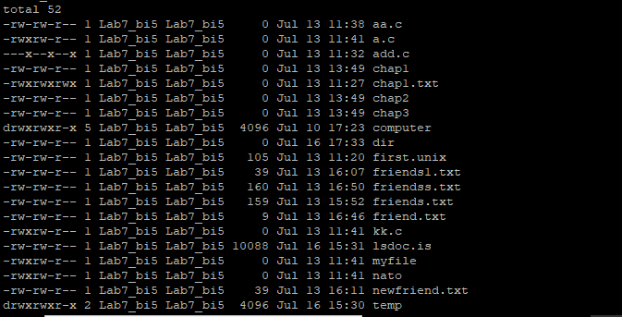
3. cut -c1-10,49-62 dir

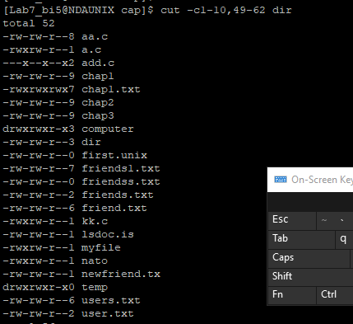

1. cut –c49-62 dir>files.txt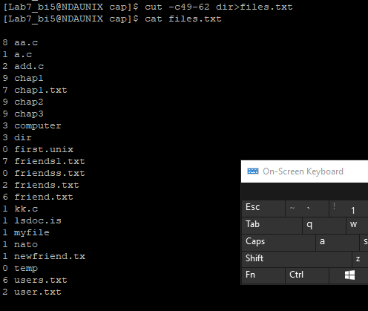
2. cut -c1-10 dir>perms.txt 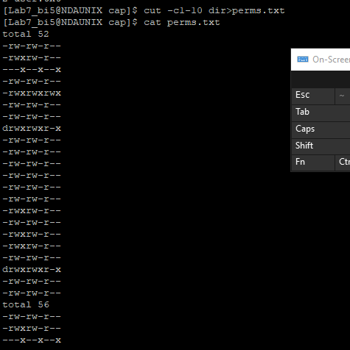
3. cut -c32-36 dir>perms.txt 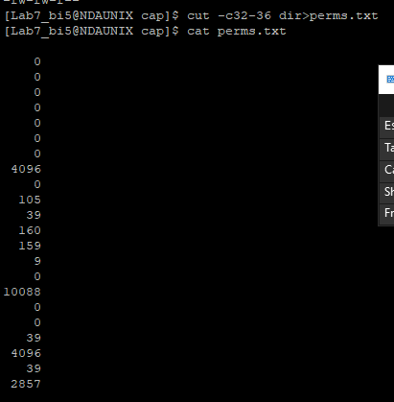
4. cut -c49-62,32-36,1-10 dir 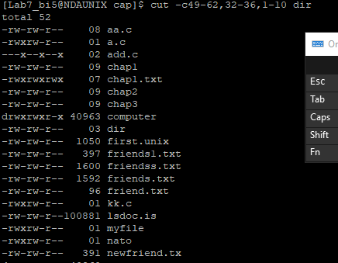
5. who

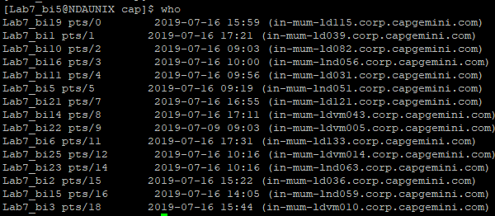

1. ls -lS | tail -1 
2. wc –l friends.txt



3. date "+%T %A %d %h %Y" 
4. ls -l |sort -t" " -r -k2 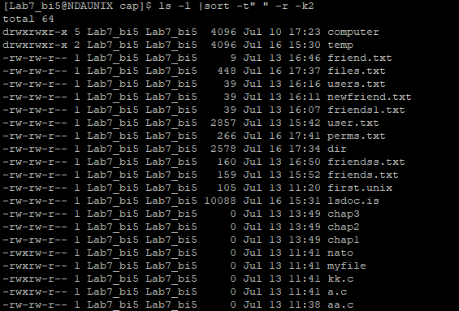
5. ls | sort

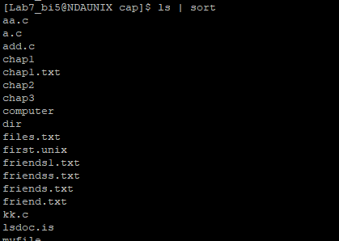

1. ls -lS | cut -c31-36,50-55 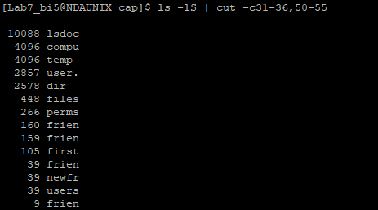
2. ls -ltr | tail -1 